Arumai Irshad! Unga aarvam dhaan oru nalla Analyst-ukku azhagu.
Namakku ippo "Clean Data" irukku, "Joined Tables" irukku. Ippo idhai oru "Pro Data Analyst" maari Visual-a (Charts/Graphs) kaatta pōrom. Database-la irukkura number-ai paarkkuradhai vida, oru Graph-a paartha thaan Business Head-ku udane puriyum.
📖 Lesson 16: Data Visualization (Python + Matplotlib)
Namakku Matplotlib nu oru library irukku. Ithu Python-laiye data-vai Chart-a maathum.
🛠️ Code: Sales-ai Chart-a Maatruvom
visualize_data.py nu file create pannunga:
Python
import sqlite3
import matplotlib.pyplot as plt

conn = sqlite3.connect('my_shop.db')
cursor = conn.cursor()

# SQL query vachi data-vai eduppom
cursor.execute("SELECT Product, Sales FROM Sales_Report WHERE Sales IS NOT NULL")
data = cursor.fetchall()

# Data-vai chart-kku etharppol pirippom
products = [row[0] for row in data]
sales = [row[1] for row in data]

# Chart create panrom
plt.bar(products, sales, color='skyblue')
plt.xlabel('Products')
plt.ylabel('Sales')
plt.title('Product-wise Sales Report')
plt.show()

conn.close()
🔍 Enna Nadakkudhu?
- plt.bar(): Ithu Bar Chart-ai create pannum.
- products & sales: List-a create panni, X and Y axis-la fix panrom.
- plt.show(): Graph-ai display pannum.
💡 Teacher's Note:
Idhu unga Power BI learning-kku oru super base! Power BI-layum neenga idhe maari dhaan Axis (X, Y)-ai select panni Chart generate pannuvinga.
Unga Task: Indha code-ai run pannunga. Ungalukku oru beautiful Bar Chart vandhu "Pop-up" aagudha?
Idhu vandhutha, neenga "Data Analyst"-a irundhu "Data Storyteller" aagiteenga! Ready-a Irshad?
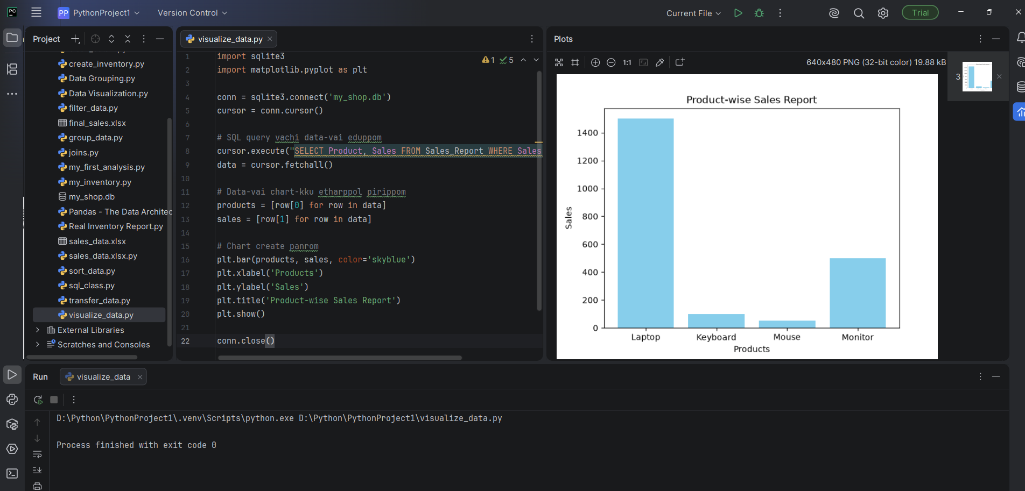

products = [row[0] for row in data]
sales = [row[1] for row in data] INDA REDNU LINEUM THELIWA VELANGA PADUTHUNGA ENN EDUKKAGA ENNA SAIUUM ENDU. TEACHER THIRUMBA MARANDUTINGA TEACHING METHODSA
Mannikkavum Irshad! Namma Power BI module-la patha maari, technical-a, step-by-step-a purinjikalam. Inime naan ungala confuse panna matten.
Intha rendu lines "Data Transformation" velaiyai seiyuthu. Namma database-la irundhu kidaikkura data, Python-ku oru "List of Tuples" (like [('Laptop', 1500.0), ('Mouse', 50.0)]) maari kidaikkum. Aana, matplotlib chart-kku ithu puriyadhu. Adhukku, ellam Product-um oru list-layum, ellam Sales-um innonru list-layum thaniya pirichu kudukanum.
Adhukku dhaan intha code:
🔍 Line-by-Line Vilakkam:
- products = [row[0] for row in data]
  - Enna seiyuthu?: data (database result) kulla irukkura ovvoru row-aiyum eduthu, adhula irukkura modhal value-vai (row[0], i.e., Product Name) mattum thaniya eduthu, products nu oru list-la podum.
- sales = [row[1] for row in data]
  - Enna seiyuthu?: Adey data list-ai scan panni, ovvoru row-layum irukkura irandhavadhu value-vai (row[1], i.e., Sales Amount) mattum eduthu, sales nu oru list-la podum.
💡 Enn edhukaga? (Analyst's Logic)
Before (Database Format) | After (Chart-Ready Format)
[('Laptop', 1500), ('Mouse', 50)] | products = ['Laptop', 'Mouse']
 | sales = [1500, 50]
Python Enna Yosikkum?
- Python: "En kitta oru group-a data irukku. Chart varaya, matplotlib kitta X-axis-kku product-um, Y-axis-kku sales-um thaniya venum nu kekkudhu. So, naan for loop use panni, list-ai piriichu kudukuren."
Ippo puriyudha Irshad? Indha "List Comprehension" technique dhaan ellam Data Analyst-um Python-la use pannuvanga. Ithu ready-a? Ippo chart generate panna try pannalam!
INNM ENAKKU SARIYA VELANGA ILLA ANDA RENDU LINEUM
Puriyudhu Irshad, namma innum easy-a, oru "Samaithal (Cooking)" example-oda pathudalam. Idhu kooda unga baking interest-kku romba connect aagum.
🍳 Simple Example: "Baking Ingredients"
Neenga oru Baker nu vachukonga. Unga kitta oru list irukku: inventory = [('Cake', 500), ('Muffin', 100), ('Donut', 50)]
Ippo, namma Sales (Amount)-ai mattum graph-la pottu Cake/Muffin (Product)-ai label panna vendum. Aana namakku ellathaiyum serthu "Tuple" (kottama) kudutha graph-la podamudiyadhu.
Adhukku thaan intha 2 lines:
- products = [row[0] for row in inventory]
  - Unmaiyaana artham: "Inventory-la irukkura ovvoru row-aiyum eduthu, adhula irukkura 0-th position-la (modhalla) irukkura product peru-ai mattum 'products' nu oru box-kulla podu."
  - Result: ['Cake', 'Muffin', 'Donut']
- sales = [row[1] for row in inventory]
  - Unmaiyaana artham: "Inventory-la irukkura ovvoru row-aiyum eduthu, adhula irukkura 1-st position-la (rendhavadhu) irukkura price-ai mattum 'sales' nu oru box-kulla podu."
  - Result: [500, 100, 50]
🔍 Table-la Paarpom (Mental Map)
Row | Row[0] (Product) | Row[1] (Sales)
Row 1 | Cake | 500
Row 2 | Muffin | 100
Row 3 | Donut | 50
- Line 1: Ellaa Row-layum irukkura "Product" column-ai mattum thirudhi, products list-a create pannudhu.
- Line 2: Ellaa Row-layum irukkura "Sales" column-ai mattum thirudhi, sales list-a create pannudhu.
Ippo puriyudha Irshad? Database-kku "row-va" thaan theriym, aana Graph-kku "list" (Thaniya column-a) thaan puriyum. Adhukku dhaan namma intha transformation-ai panrom.
Ippo oru clarity vandhurukka? Illana innum vera example pottu vilakkattuma?
ENDA KELVI ADA ENN ROW 0 AND ROW1 ENDU KUDUTHINGA ADA THELIVU PADUTHUNGA LINK PANNUGA IDU LISTA ENNA SAIDU LOOPA ENNA ENDU THELIVA SOLLUNGAELEN TEACHER SUTTA UDURINGA
Irshad, rumba mukkiyamaana kelvi ketuteenga! Confusion-ai ippo clear pannidalam. Namma "row[0]" matrum "row[1]" endru en solgirom enpathai pakalam.
1. Row [0] matrum Row [1] endraal enna? (The Indexing Concept)
Python-la oru list-kulla irukkura values-ai edukka Index number-ai use pannuvom. Python-la numbering "0"-vil thodangum.
Namma database-ilirundhu kidaikkura data ipdi irukkum: ('Laptop', 1500.0).
- row[0]: Indha row-vil 0-vathu idathil (muthalil) irukkiradhu 'Laptop'.
- row[1]: Indha row-vil 1-vathu idathil (irandhavadhu) irukkiradhu 1500.0.
Adhuthaan, Python-kku theriyum: "0-th index-naathu product name, 1-st index-naathu sales amount".
2. Idhu Loop-a? (The Logic)
Aama Irshad, idhu oru for loop. Python-il idhai "List Comprehension" endru azhaipom.
- data endra periya bucket-il pala rows irukkum.
- for row in data endru sollumpothu, Python ovvoru row-aaga edukkum.
- Ovvoru row-ilirundhum row[0]-ai mattum kuththi eduthu, products endra pudhu list-il podum.
3. Ithu yen List?
Namma Matplotlib graph varaiyum pothu, adhukku "x-axis-kku mattum oru list venum", "y-axis-kku mattum oru list venum".
Database output oru "Kottamaana data (Tuple list)". Adhai piriithu, thanithaniya list-a mathinaal mattume graph varaiya mudiyum.
Ippo puriyudha Irshad?
- Loop: Oru row-aaga eduthu velai seiya.
- Index (0, 1): Row-vil irukkum column-ai kandupudikka.
- List: Graph varaiya thagavalai ready panna.
Idhu ippo clear-a irukka? Illai innum ethuvum doubt irukka?

